**Steps to implement the Client system**

1. To get the IP address

Ifconfig

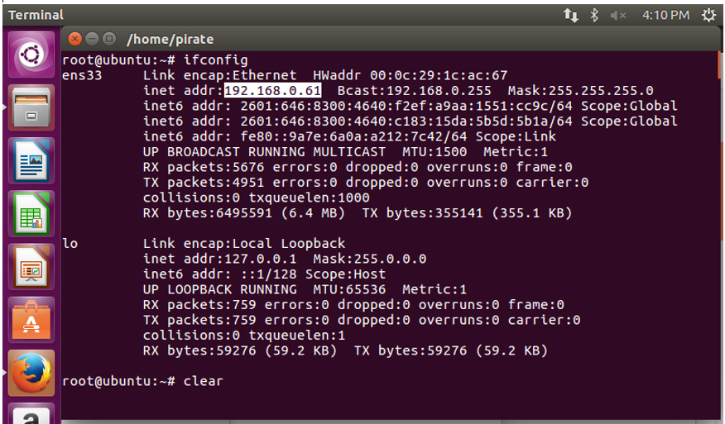

1. To scan the network to discover Raspberry

sudo nmap -sP 192.168.0.61/24 | grep -B 2 "Raspberry"

Nmap scan report for 192.168.0.37

Host is up (0.0020s latency).

MAC Address: B8:27EB:71:30:07 (Raspberry Pi Foundation)

1. For logging into the host machine

ssh [pirate@192.168.0.37](mailto:pirate@192.168.0.37)

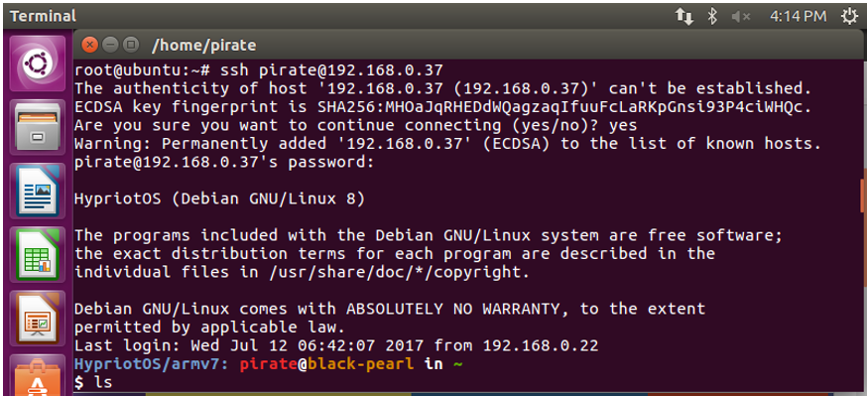

1. To enter the directory

cd ecep_client/

1. To execute the shell script

sudo ./ecep_client.sh

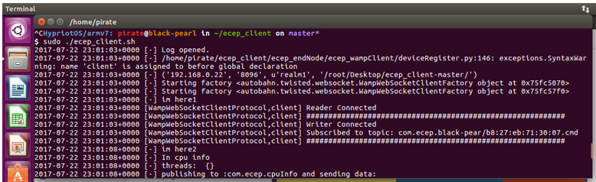

Finally, the reader and writer are enabled.